Refer to the given schema.

Write a query which fetches  the studentName, Standard, Student average marks, Gen Science ,Mathematics Scores for the students , whose average marks is greater than or equal to 75% as well as their Science & Mathematics marks ,individually greater than or equal to  75% and also print the Total of Science &Maths marks with a Caption 'Science&MathsTotal'.

Hint: **Data is case sensitive**

**NOTE: Maintain the same sequence of column order, as specified in the question description**

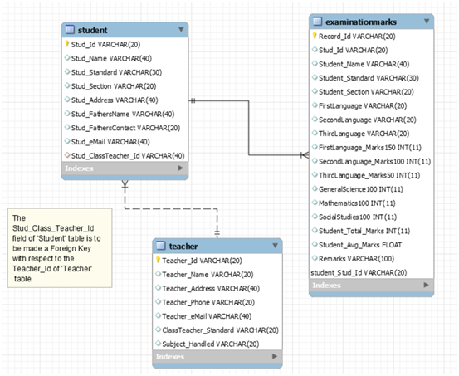

USE CodeChallengeDB;

CREATE TABLE ExaminationMarks(

Record_id VARCHAR(20) PRIMARY KEY,

stud_id VARCHAR(20),

stud_name VARCHAR(40),

stud_standard VARCHAR(30),

stud_section VARCHAR(20),

FirstLanguage INT(20),

SecondLanguage_Marks150 INT(20),

ThirdLanguage_Marks100 INT(20),

GeneralScience100 INT(20),

Mathematics100 INT(20),

SocialScience100 INT(20),

Student_Avg_Marks INT(20),

Remarks VARCHAR(20)

);

INSERT INTO ExaminationMarks VALUES('R3','24','Gautham','10','A',30,40,45,30,30,56,35,'Try');

SELECT stud_name, stud_standard, Student_Avg_Marks, GeneralScience100, Mathematics100, GeneralScience100+Mathematics100 AS ScienceMathsTotal

FROM ExaminationMarks

WHERE Student_Avg_Marks >=75 AND GeneralScience100 >= 75 AND Mathematics100 >=75;